**Name: Piyush Vishnoi**

**Roll no: 71**

**Sap id: 500067083**

**Experiment – 12**

**Lab Experiment - 13**

**Docker commands**

STEP - 1

Command:

docker search redis

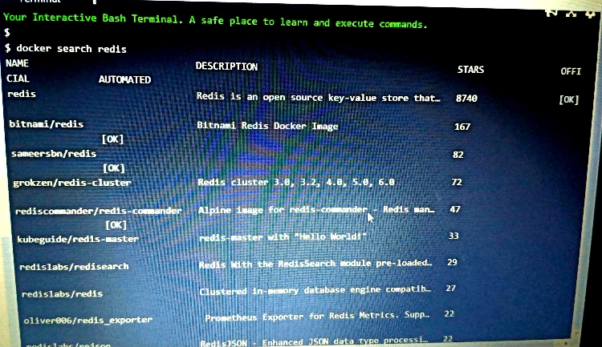

Command: docker run -d redis

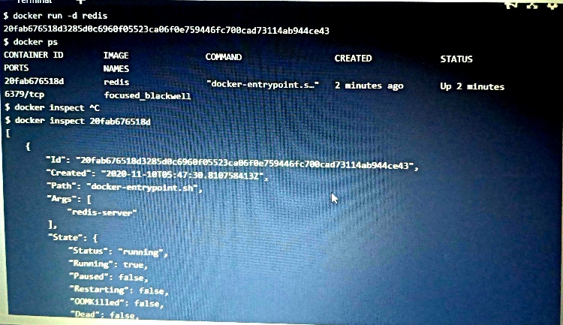

STEP-2

docker ps

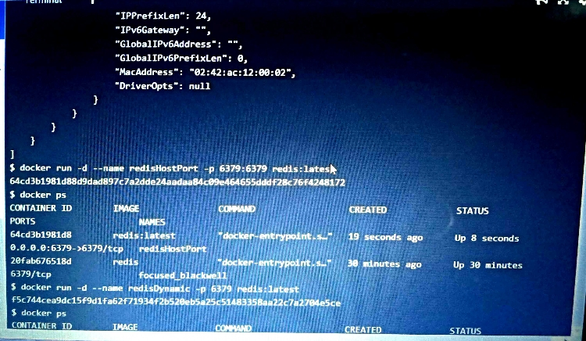

**docker inspect <friendly-name|container-id>**

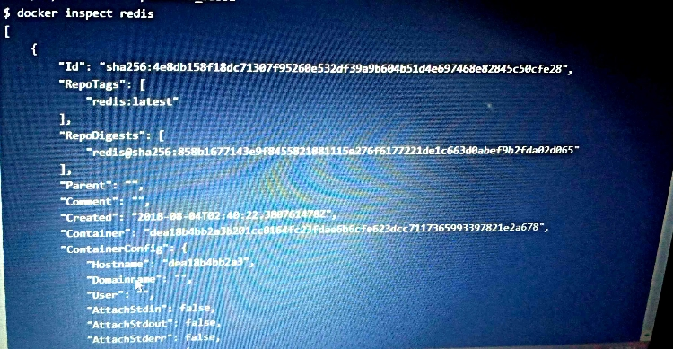

**Step -3**

**Accessing redis**

**docker run -d --name redisHostPort -p 6379:6379 redis:latest**



**STEP - 4**

**docker run -d --name redisDynamic -p 6379 redis:latest**

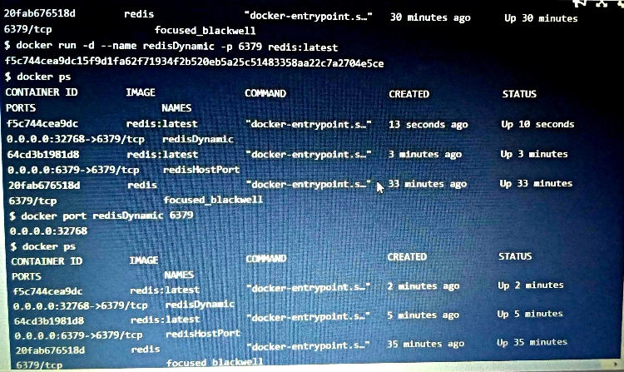

**docker port redisDynamic 6379**

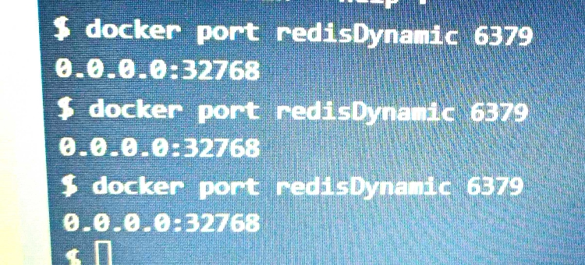

**STEP-5**

**docker run -d --name redisMapped -v /opt/docker/data/redis:/data redis**

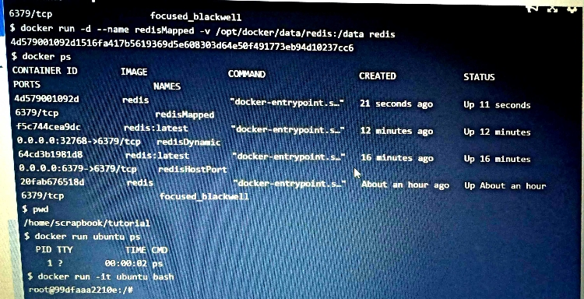

**STEP - 6**

**docker run ubuntu ps**

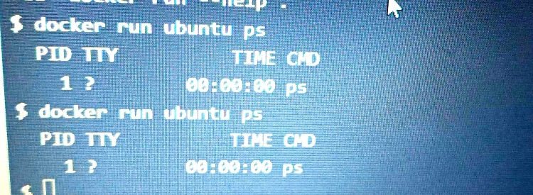

**docker run -it ubuntu bash and finally in root**

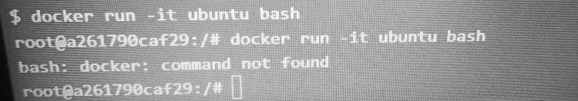

docker ps